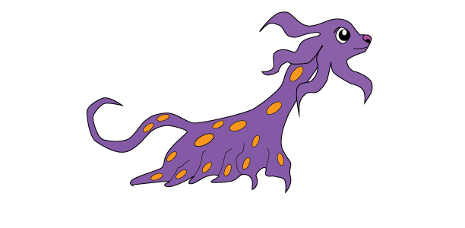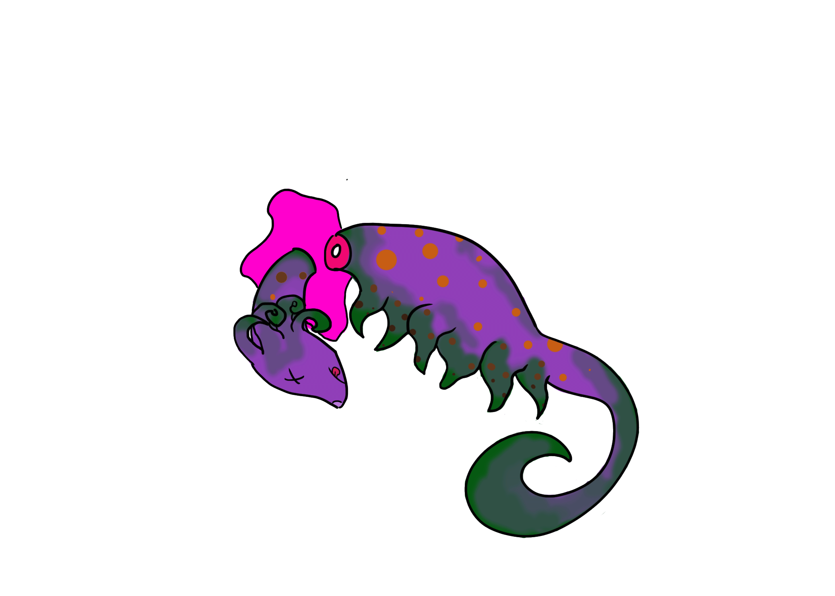
Who Whacked Tutu?
Design by Kayla Harris
Created by Team 5 Hamsters (Kayla, Jarrett, Victoria, Megan, Ben)
10/29/2015
For PC & MAC
Ages: Rated T for Teen
Ship Date: Dec 17, 2015

High Concept: Monsters of all kinds attend the fantasy University of Monstrosity that is known for its fraternity culture and it is here that you play as a pledge who has just passed initiation into the coed fraternity RealMon. Who Whacked Tutu? is a first person point and click mystery adventure where the player has to find out who killed the frat leaders’ younger sister’s pet saber tooth kitten tentacle monster within the allotted time of 30 minutes.

Game Story Summary: Who Whacked Tutu? takes places in a fictional world at the University of Monstrosity, a university that monsters of all kinds attend. The previous night was Halloween, one of the biggest holidays of the year. That night was also your initiation night in order to be inducted into the highly influential coed fraternity of RealMon. For the final task before being inducted into the fraternity you and the other pledges had to bring back something completely killed or destroyed. The big brother and big sister fraternity leaders often take part in the event as well because it is always exceptionally festive. However, the fraternity has two rules for new and incoming pledges. The first rule is that at the final event either all pledges pass or fail. Therefore even if only one pledge does not bring back something completely killed or destroyed all pledges would fail. This is used to promote teamwork and comradery between the pledges. The second rule is that no one can know which completely destroyed or killed specimen belongs to which pledge. This is in order to keep the pledges humble instead of boasting the greater achievements of those that are better at killing and destroying. The morning after the crazy Halloween party night, all pledges have brought their destroyed specimen therefore all pledges have passed. Suddenly, frat leader Brad’s younger sister Little Baby Daisy, a ginormous and violent monster, has ran through the door screaming that she cannot find her pet saber tooth kitten tentacle monster. That’s when she sees her dead pet lying on the floor next to you! This obviously makes it look like you killed her pet. Brad attempts to calm her down and says that everything will be alright. This is when Brad receives a phone call from his mother. He left his laundry at his parent’s house again and his mother will be at the frat house in 30 minutes to drop it off. You freak out and say that you will clear your name because you did not kill her pet. Now you only have 30 minutes to relieve yourself of the blame!

Game Flow Outline: Who Whacked Tutu? is a first person point and click adventure game. The game begins in the common room of the fraternity house. You are the main character. You wake up in the common room next to a dead saber tooth cat tentacle monster. All of your fraternity pledge brethren are standing around you as you wake up. There is Stefanie, the werewolf that is on a diet. Bekka, the super nerdy turtle shell monster. Troy, the muscle bound alligator ape, and Kris the vampire that is obsessed with his hair. They all call you a lightweight since you were passed out from ingesting too much alcohol. This is when Little Baby Daisy comes running through the door screaming that she cannot find her pet saber tooth tentacle monster, Tutu. Her screaming prompts her older brother and Frat leader Brad to stumble out of his room in a drunken stupor. She squeezes Brad, but then she sees her pet dead on the floor. The pet is often at the Frat house, however on this night Tutu was originally home with Daisy. Since you woke up next to the dead pet, everyone thinks that you killed it for the fraternity’s last mission. You are adamant that it was not you that killed Tutu. This is when Brad receives a phone call from his mother. She states that she is coming over to drop off his laundry since he left it at his parent’s house again. Brad’s mom will arrive in 30 minutes. Brad assures Daisy that they will find out how Tutu died and catch whoever did it. Little did you know that Brad is the actual killer! This is when you take control of the game. In order to clear your name you start looking for clues to prove that someone else did it. You are able to explore the common room, kitchen, girl’s frat room, boys’ frat room, the front yard, Brad’s room, bathroom, and the backyard. You will need to collect evidence from the various rooms in order to accuse someone of the crime of killing Tutu. You need at least 3 pieces of evidence in order to accuse someone of killing the pet. Will you be able to catch the culprit, and relieve yourself of the blame before Brad and Daisy’s mom arrives?

Character: Nameless main character. The player names their character at the beginning of the game. You are a monster, however because the game is first person you cannot see yourself. Your defining traits are righteousness and justice and you always seek the truth. You are very similar to Detective Conan and Sherlock Holmes in that you have an inquisitive nature. The fact that you are being accused of the crime is eating away at your psyche.

Controls: Who Whacked Tutu? uses the following controls to play:

• Left-Click – For interacting with the environment and characters; to move
• Keyboard – Only used at the start of the game to enter your character’s name

Gameplay Overview:
· The mood and theme of the game is “Murder Mystery.” A Halloween themed monster college fraternity house.
· Perspective – 2D
· Camera – 1st person camera
· The main playable character will not have any health meters. The game ends either when you present evidence to convict someone of the crime or when the timer runs out.
· There will be a timer in the top right corner counting down from 30 minutes. Before the timer hits zero you have to present the evidence that you’ve found in order to pin the pet murder on someone. If you do not present any evidence before the timer runs out, you will be blamed for the murder.
· There will not be any loading screens.
· The player will need to collect evidence against any of the other fraternity pledges or the fraternity leader. These items will be stored in the notebook.
· There will not be any saving in the game
· The game will only be playable on Mac & PC.

Game World:
• The game takes place in a fictional world at the University of Monstrosity. This world is inhabited by monsters, ghouls, goblins, and humans.
• The main setting will be at the RealMon fraternity house. The house has several rooms:
- Common Room - a really messy area where it is obvious that a Halloween fraternity initiation took place the night before. The pledges have left their last mission killed specimen in here.
- Boys Frat Room - workout equipment, their favorite rock bands on the walls
- Girls Frat Room - nerdy girl computer, food for a girl who is on a diet, favorite boy band pictures on the walls
- Brad’s Frat Leader Room - guitar, rock and roll, family photos
- Kitchen - with a refrigerator stocked full of Hamsters, a clickable microwave to microwave the hamsters
- Bathroom - green monster goop coming out of the sink, the tub is filled with water
- Front yard - green grass, a messy lawn from the previous night’s party
- Backyard - tombstones, bones, basketball with basketball goal
• Throughout the game mysterious music will play. If the player goes outside to the front or backyard then outside noises such as crickets will play.

Game Experience:
· When players first start the game they will see dialogue that is a synopsis of the story and game world. The game will then open with all of the fraternity pledges standing over you as you are waking up in the common room.
· The start screen will be have a cute and lively Tutu, the saber tooth monster tentacle cat, happily looking at you. The emotions and mood that the game is meant to have is that of a “mystery Halloween party.” Most scenery should give players the impression that a party took place the night before. However, there should also be very obvious dead things lying on the floor and other places. The player should feel curious as to what those items are and how they got there.
· Music and sound will be able to convey the game's’ overall feel by being eerie and mysterious. When the player goes outside the music should change to outside sounds that are similar to crickets chirping.
· Players navigate the game by clicking with their mouse in order to get around. Arrows can also appear if they player is sitting idle for too long.

Gameplay Mechanics: These are some of the hazards and mechanics in the game:
Hazards: There are not any hazards in the game that can hurt the player. Except Little Baby Daisy’s hugs or cries. She does not know that she is hurting you. However, you will not lose health from her dangerous hugs or sad cries.
Collectibles:
The only items that the player will need to collect is evidence such as beer bottles, clothes pins, fingerprints, or anything else that can help the player to determine who killed the Tutu, the pet saber tooth tentacle kitten.

Power-Ups:
There are not any power-ups in this game.
Enemies:
· There are not any enemies in this game. The player loses if they do not accuse a monster of the crime or if the timer runs out.

Multiplayer and Bonus Materials:
· This game is a single player game.
· The player will be able to receive extra time to their timer if they are able to find certain clues or evidence fast enough.

Monetization:
· The game will be available for free to GAME 210 classmates and professors. Otherwise the game will be $1.99 and downloadable on Steam.

Mock HUD:
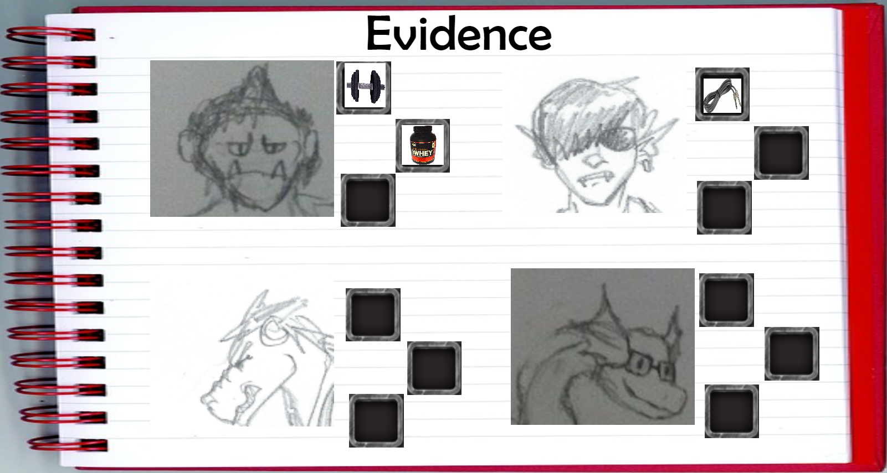
Mock Level Design:

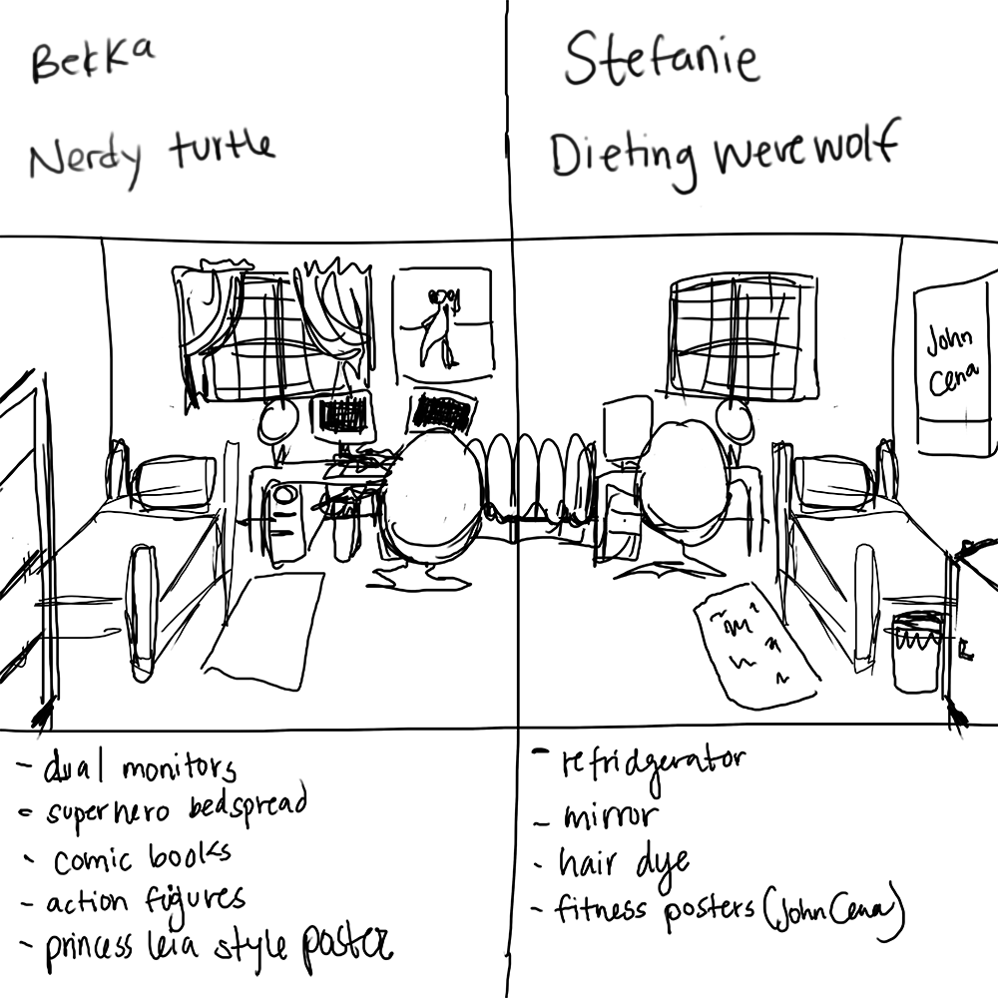
Concept Art:
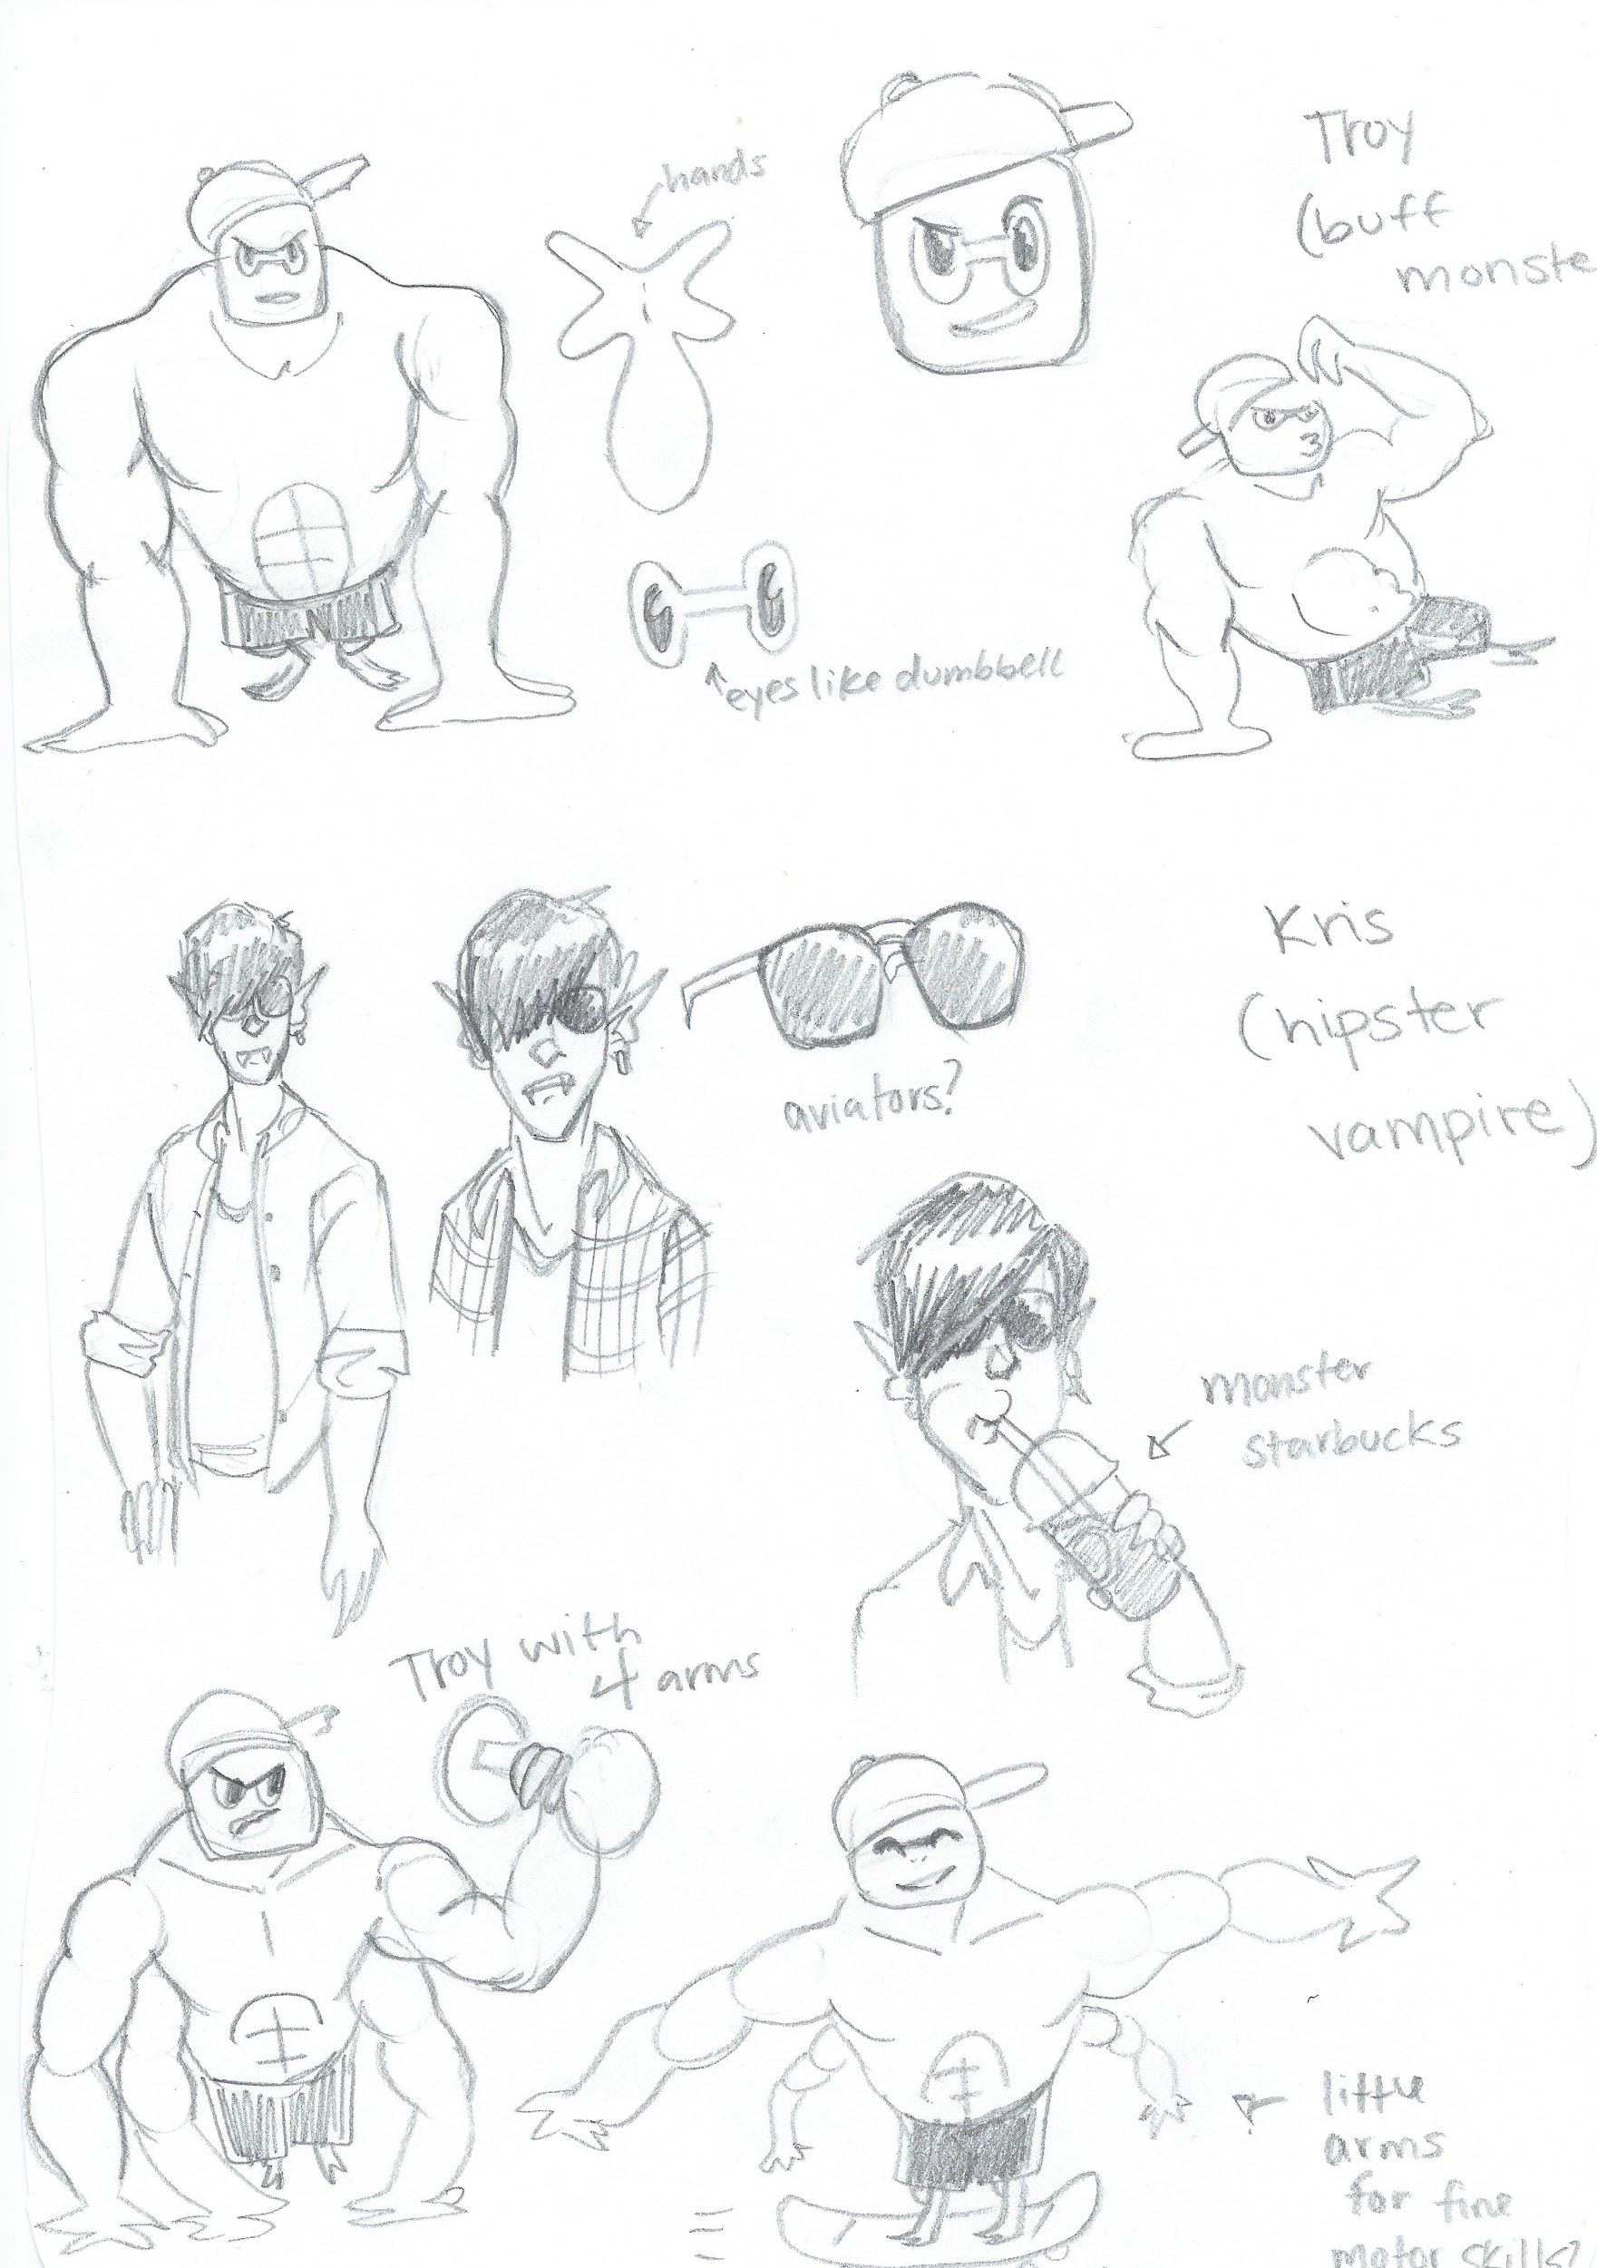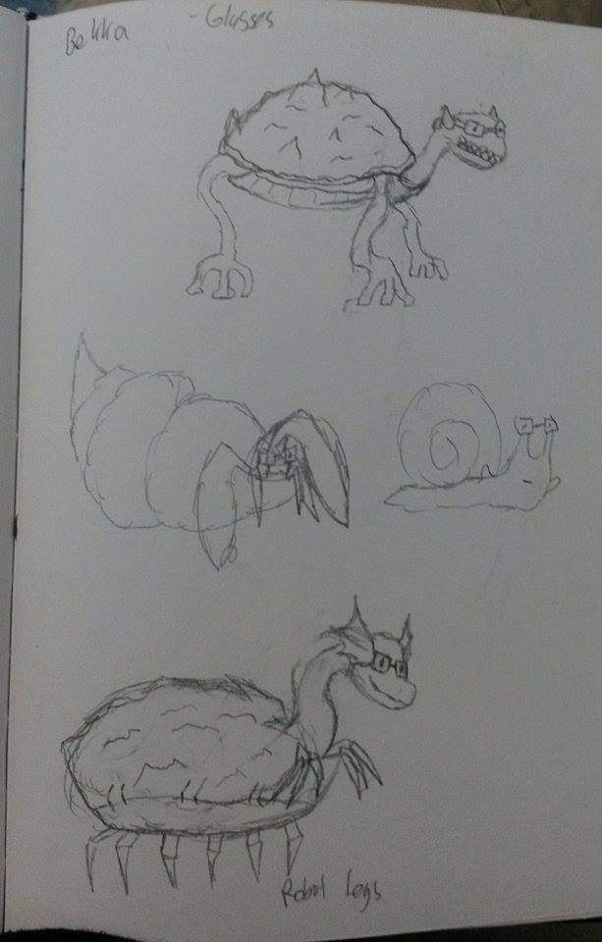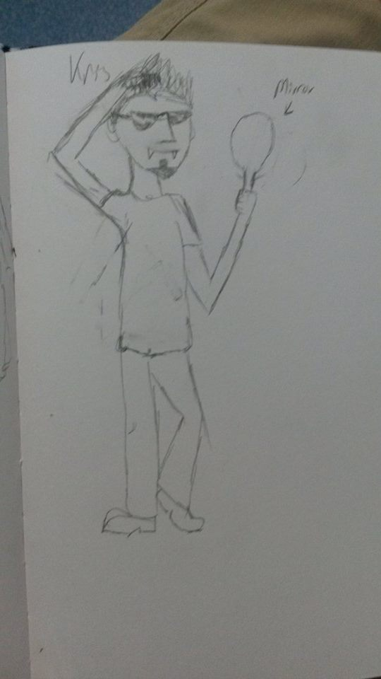 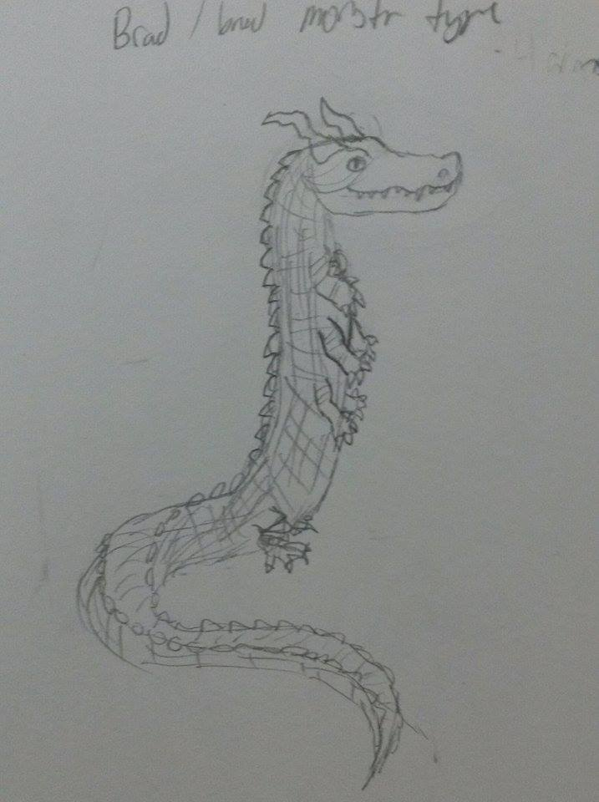Fubak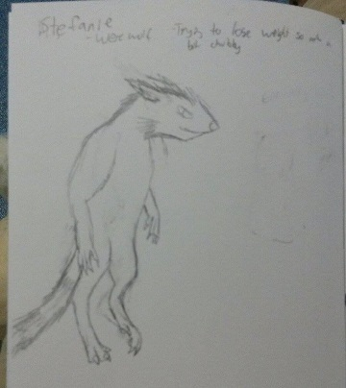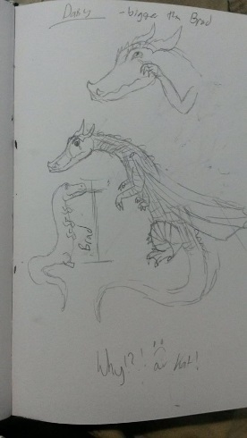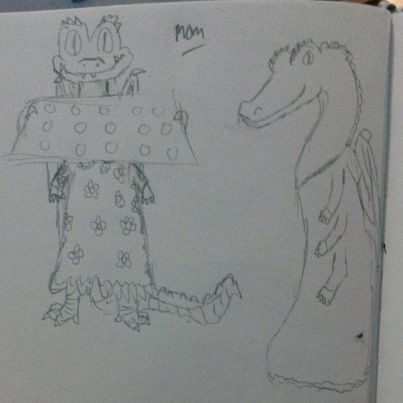
Dead Sabertooth Tentacle Monster Cat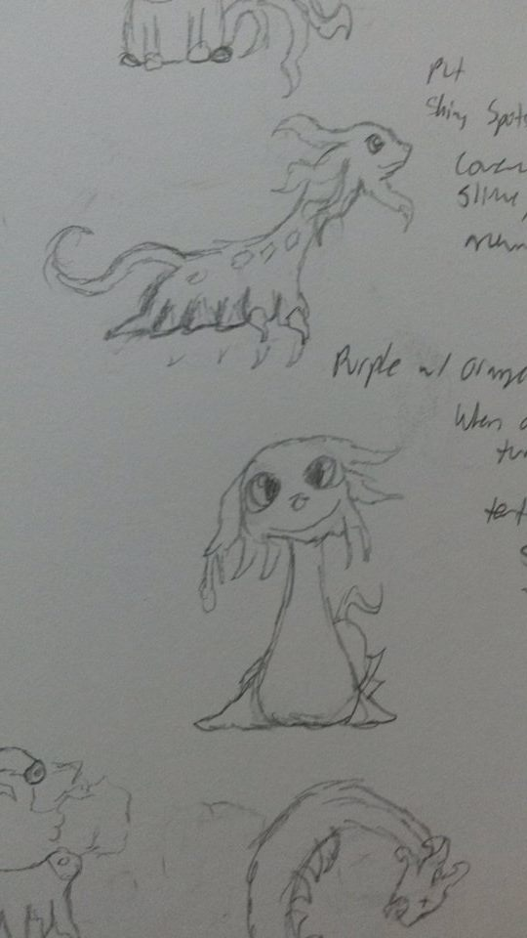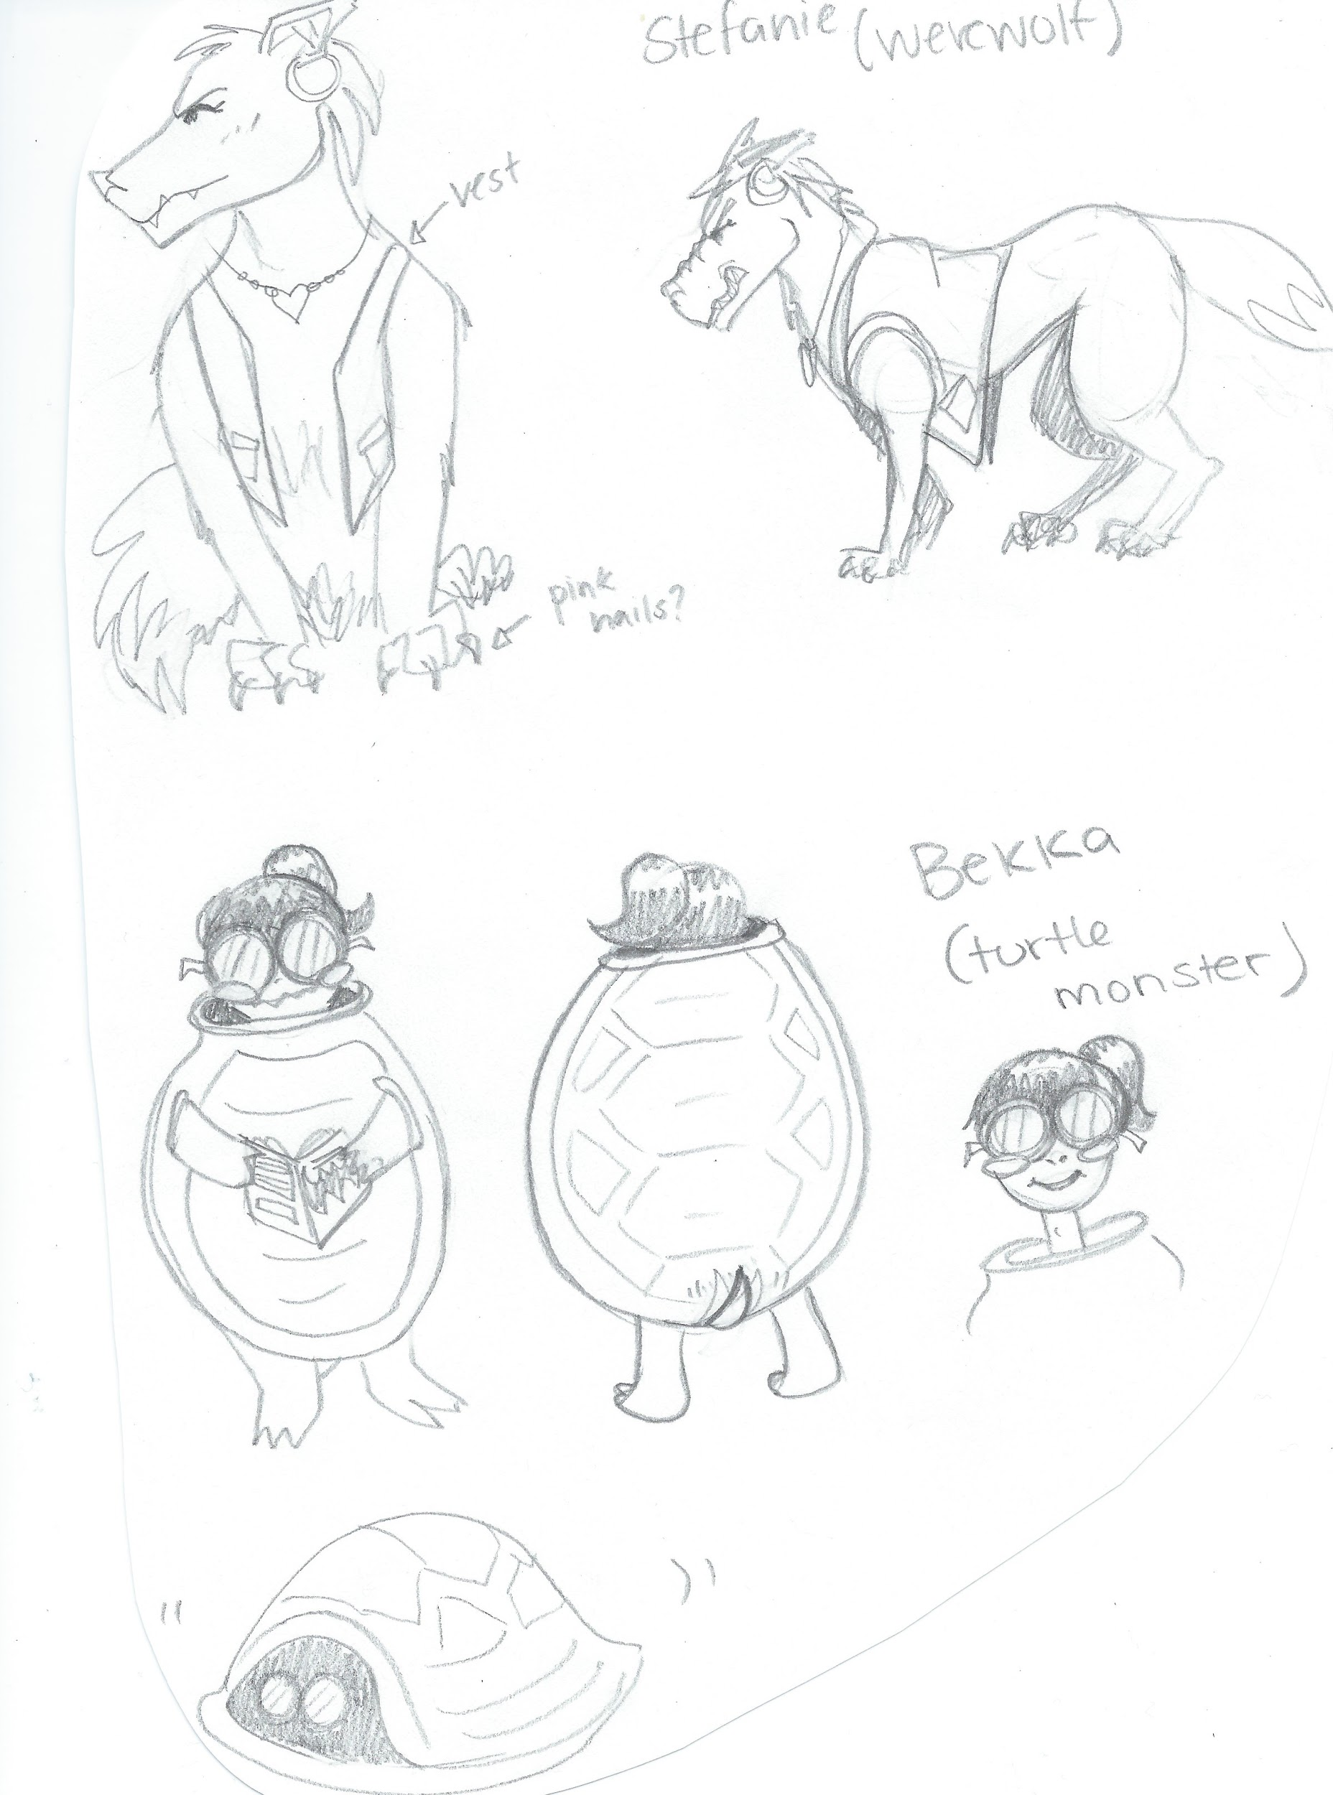

Final Art Work:
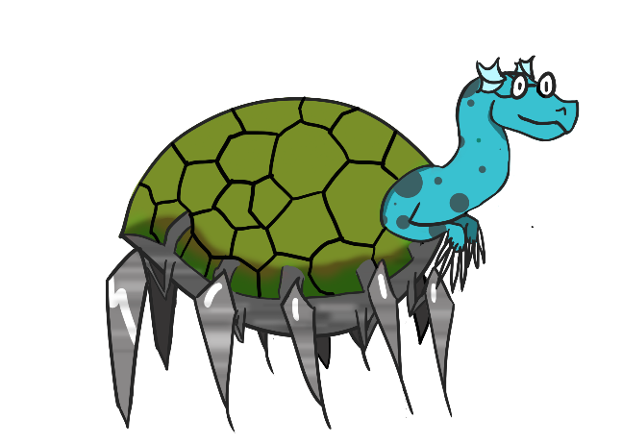Bekka & Brad
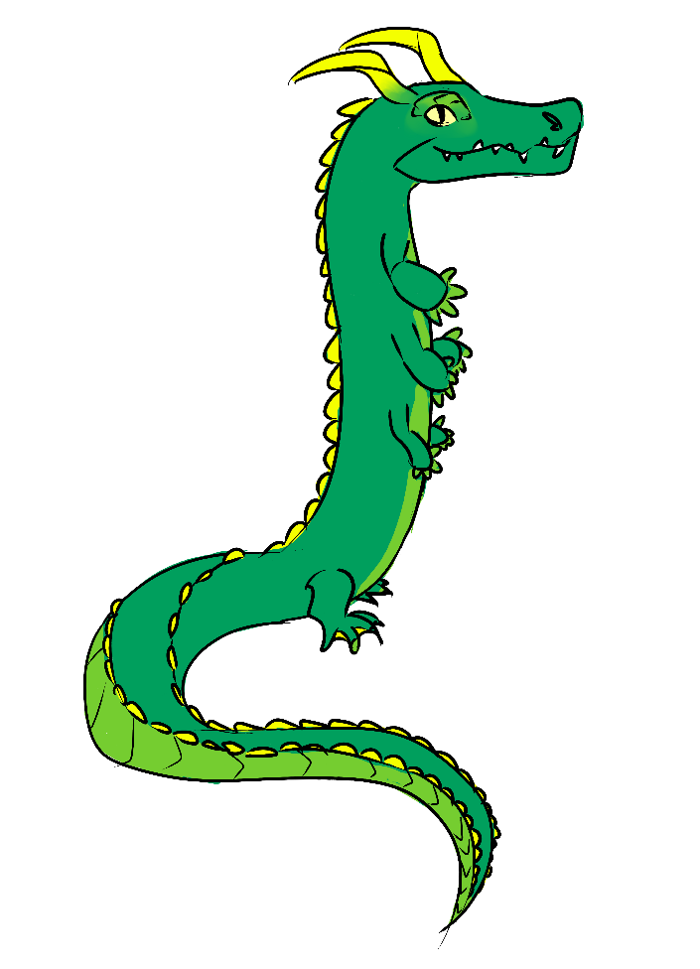
Brad & Daisy’s Mom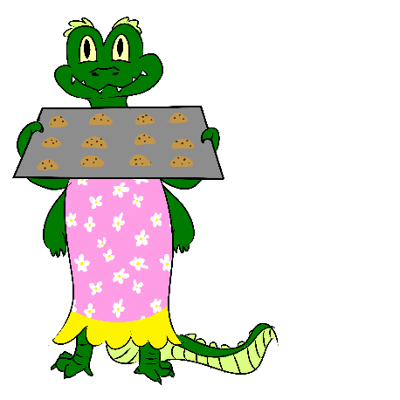
Daisy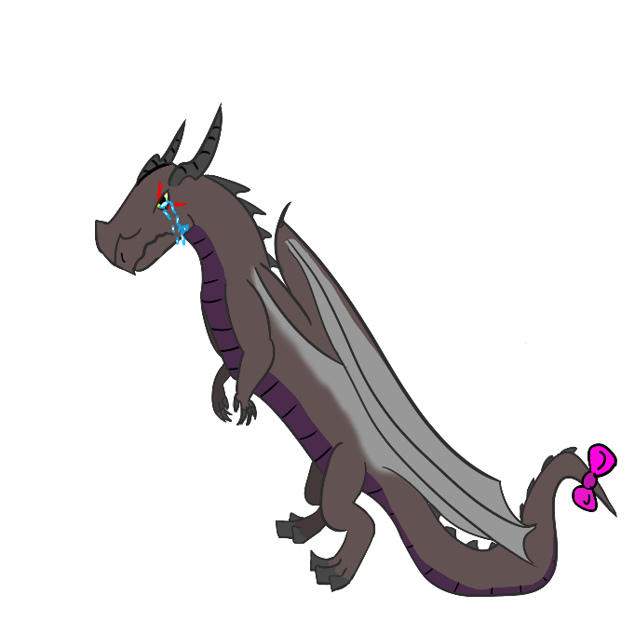

Stefanie
Troy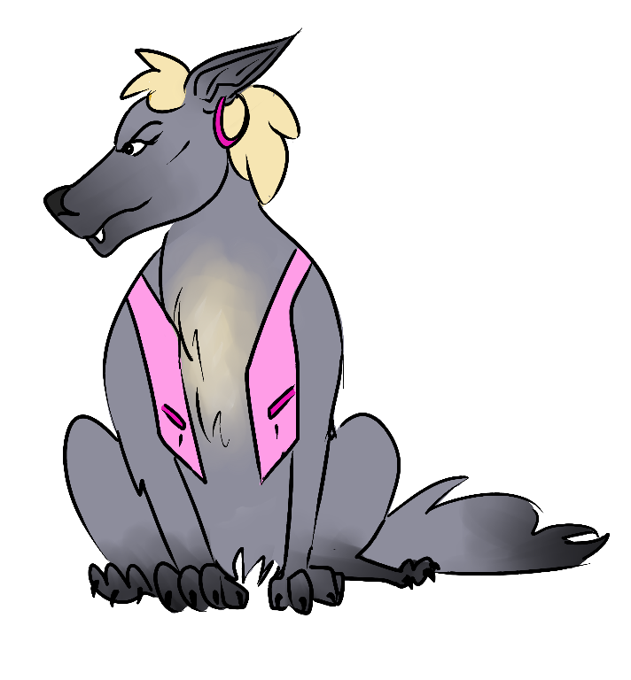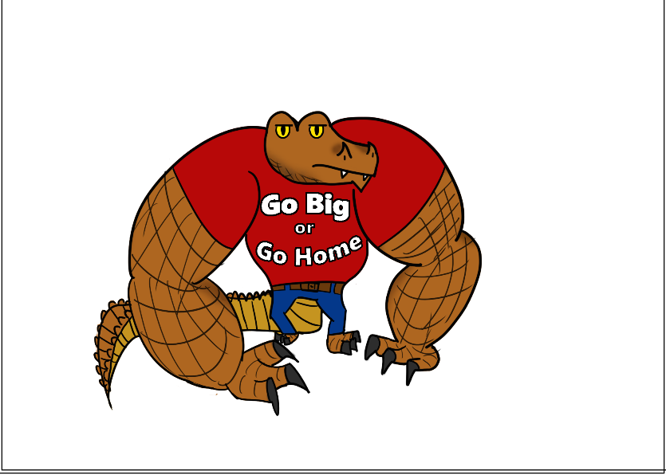
Final Level Designs: 