
KLOUD
Design By: Kayla P. Harris
9/20/2016
For: pc
Ages: rated m; 17 – up
Ship date: tbd

High Concept
Kloud is an open world third-person action-adventure beat ‘em up where you play as a memoryless young woman who wakes up in a warehouse with only a cell phone that has a voice recording. A woman on the voice recording calls you Zacharie, and tells you that you need to save your husband Agent XQ, whom you don’t even remember right now. Although you feel a burning desire to save him you are unaware that by doing this you are really taking on the entire ominous Kloud organization.

Game Story summary
Kloud is the evil organization. Its members are all everyday people. Doctors, lawyers, politicians, school teachers, athletes, etc. Kloud is called “kloud” because its reach and influence covers everything under the clouds. They're responsible for everything that is wrong with the world. They communicate on the black underground internet network that is based off of the real world Dark Net that real life bad guys, drug dealers, and hackers use.
You don't have any memories. You used to be a member of Kloud, however you don’t currently remember this. After being knocked out and injected with a memory serum you wake up in an abandoned warehouse that used to be a mixed martial arts and boxing gym. All you have on you is a cell phone with a voice recording. A woman’s voice calls you Zacharie, and tells you that you need to save your husband. You must now navigate the city, skillfully use the dark net and acquire information from seemingly everyday people in order to save your husband while also chipping away at the Kloud organization’s stronghold on the city of Seattle.
Game flow outline
You wake up in an abandoned warehouse that used to be a mixed martial arts and boxing gym. This is the tutorial area where you, the player, learn how to fight by interacting with the world and practicing in the gym. All you have on you is a cell phone with a voice recording. You actually recorded this, but you don't remember doing it right now for some reason. Maybe you have a friend that helped you get out of your previous sticky situation and that's also why you still have this phone on you.
On the recording you hear a woman call you Zacharie. This must be your name. After listening to the first recording you realize there's a second recording. It's a woman's voice. She tells you that you need to save your husband, Agent XQ. But you don't remember him. But you feel a burning desire to help this guy. Little do you know that on your way to simply save him, you will really be taking on the entire Kloud Organization. Your husband Agent XQ is the current stand in for the head of the Kloud Organization. However only the people that knocked you out and injected you with a memory serum know this. The person who injected you doesn't like fighting or killing women. So he takes pity on you, and has you discarded instead of killed. This is the games’ opening cinematic. You need to navigate the world in order to save your husband. While encountering people that seem to know you, while you begin to recover your lost memories.
Characters

Zacharie – The main character and protagonist of Kloud. She wakes up in an abandoned warehouse and learns that she must save her husband from the Kloud Organization. Zakelina is her nickname, and when she gets certain memories back you see that she often complained about having a boy's name. So when you were little your best friend started calling you Zakelina to make her feel better. Maria is her best friend. Although Zacharie doesn’t remember this at the beginning of the game. Zacharie’s parents are a black woman and an Asian guy. They adopted her because she is bi-racial and they couldn't have children of their own. Zacharie’s father is impotent. Zacharie loves reading Shonen Jump manga and drinking strawberry milk. Zacharie met her husband, River, as a child. Even as a child he was already a member of the Kloud organization, by birth. But the player does not know any of this. This can be more back story for DLC or even game number two.

River Eschew aka Agent XQ – Zacharie’s husband, and the current boss stand in for the Kloud Organization. River goes by Agent XQ in the Kloud Organization, and only a few people know his real name. He goes by XQ because it sounds similar to his last name Eschew. He is perceived to be in need of saving from the clutches of the Kloud Organization. According to Maria at least.

Maria – Maria is Zacharie’s best friend. She is also a member of the Kloud Organization. Her voice is the one that Zacharie hears on the voice recording at the beginning of the game. Maria is a very righteous character and always does the right thing. She joined Kloud initially because she felt that the organization aligned with her righteous ideals.

Terry Treize – A guy that won’t physically harm any women or children. It’s against his personal code of ethics. At the beginning of the game he injects Zacharie with a memory loss serum instead of killing her like he was originally ordered to do.

Controls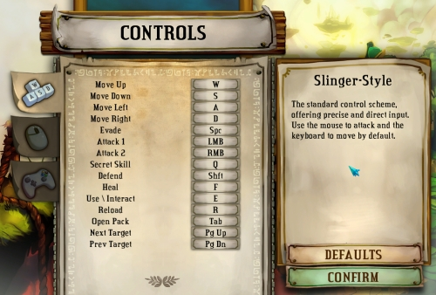

Gameplay overview
- Navigating an open world
- Driving, entering and exiting vehicles
- Fighting – Hand to hand combat, picking up weapons, and using the environment as a weapon like in Square Enix’s Sleeping Dogs. Fighting hordes of enemies like in Akiba’s Trip: Undead and Undressed.
- Unlocking memories as large puzzle pieces for 4 piece puzzles
- Hacking into systems usually with your cell phone
Entering certain areas, like a coffee shop that you and your husband went on a date in, will trigger memories that will be saved as puzzle pieces. Once you've collected all of these puzzle pieces you will have a complete picture of the puzzle that will lead you to where you need to be in order to save your husband.
Mini-games can help you improve certain skills. Like going to the gun range can increase your accuracy of landing attacks, drinking a lot of caffeine can make you faster and increase your speed, drinking alcohol can increase your drunken tai jutsu fighting skills, actually doing odd side jobs for the Kloud organization, or even doing them for normal people who aren't in Kloud, can earn you cash and either increase or decrease your notoriety depending on the type of job that you complete. Your notoriety (a cloud meter on the HUD) is essentially how aware the Kloud organization is of you, your existence, and possibly even your true intentions.
Kloud is not a stealth game, but there will be stealth elements and missions that require you to be stealthy. Like Deus Ex you can choose to not kill people. You can choose to not use deadly force when fighting. But of course cracking someone over the head with a guitar would kill them. So it's best to hit them in the body if your goal is not to kill them with a guitar, for example.

Game world
The game is set in modern day Seattle in the year 2017. Seattle is the headquarters of tech giants such as Microsoft and Nintendo. So there is a lot of technology around for Zacharie to hack into in order to gain information on the Kloud Organization. Seattle is also filled with coffee shops because it is the home of Starbucks, Seattle’s Best Coffee, and dozens of other coffee chains. There is literally a coffee chain on every corner. The world is populated with people from all walks of life. Some people are members of the Kloud. The game world will feel as if you were living in Seattle, Washington right now. The player will know how to get around by utilizing the mini map and the HUD.


Game experience
- When players first start the game they will see the opening cinematic of Zacharie being knocked out and injected with a memory serum that makes her lose her memories.
- The emotions of longing, love, happiness, sadness, and constant thrills are meant to be evoked while playing this game. There will also be comedic moments sprinkled throughout the game.
- The music and sounds convey the game’s feel of ominous foreboding most of the time. Since it rains a lot in Seattle the sounds of the weather will be brought to the forefront especially while it is raining or there are heavy winds.
- There are multiple story chapters.
- The game is open world so the game world will be split up into locations.
- Never before seen video game story where the woman has to save the man. A wife saving a husband.
- Unique even cartoonish Akiba’s Trip: Undead and Undressed style fighting system paired with realistic graphics
- Hack The Planet as a female hacker.
- Insert Uncharted 4 like Big set cinematic gameplay piece here
- Gun range minigame
- Drinking mini-game – How much can you drink before getting sick or blacking out? Challenge the guy in Pablo’s Pub to a drink off.
- Your skills are directly affected by what you do every day. So going to the gun range will increase your attack accuracy, drinking a lot of alcohol will increase your drunken tai jutsu fighting skills while drunk, and drinking a lot of caffeine from coffee shops will increase your speed and awareness.

Gameplay mechanics
Below are the hazards, collectibles, and power-ups of the game.

Hazards
- Hazards include airport terminals, computers, cash registers, automatic teller machines, traffic lights, and anything else than can be hacked into. However, this isn’t Watch Dogs 2. Everything cannot be hacked into. Only intractable terminals with interact icons will be able to be hacked into. Some hazards prevent progress of the story until traversed.

Collectibles
- The character really likes finding the new Harriet Tubman bills. So these are collectible throughout the game.
- Shonen Jump manga
- Strawberry milk

Power-ups
- The only way to gain power-ups in this game is to gain skills by fighting, hacking, or playing mini-games to increase certain skill traits.
- You also want to keep your Kloud Notoriety meter down. This cloud shaped icon on the HUD tells the player how aware the Kloud Organization is of their existence.

Economy system
- By doing jobs for random people, some are Kloud members and some are not, the player is able to earn money to buy clothes, coffee, alcohol, and even information.

Enemies
- There are two types of enemies:
  - Humans – Normal humans or members of Kloud that will fight you for a variety of reasons.
  - Machines – Such as a rogue computer terminal or a robot.

Unique selling points – usp’S
- Never before seen video game story where the woman has to save the man. A wife saving a husband.
- Unique even cartoonish Akiba’s Trip: Undead and Undressed style fighting system paired with realistic graphics
- Hack The Planet as a female hacker.
- Your skills are directly affected by what you do every day. So going to the gun range will increase your attack accuracy, drinking a lot of alcohol will increase your drunken tai jutsu fighting skills while drunk, and drinking a lot of caffeine from coffee shops will increase your speed and awareness.

Competitive products
- Uncharted 4
- Sleeping Dogs
- Tomb Raider
- Horizon Zero Dawn
- Other Open World Action-Adventure games with beat ‘em up elements or a female protagonist
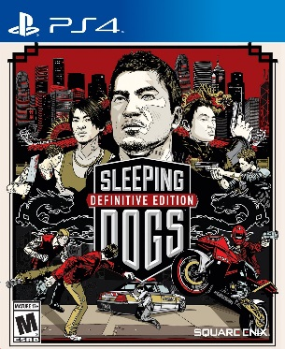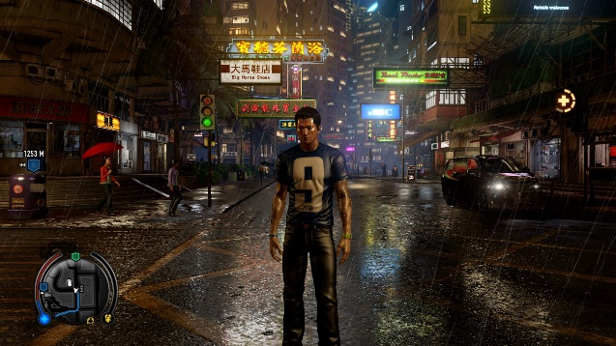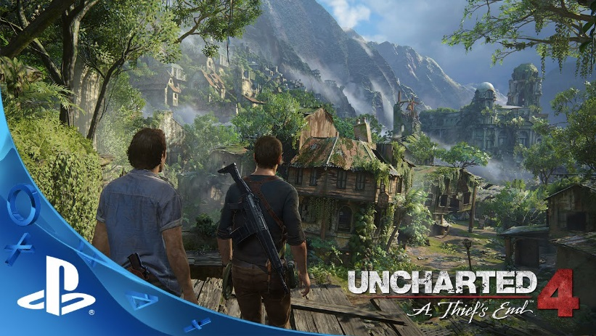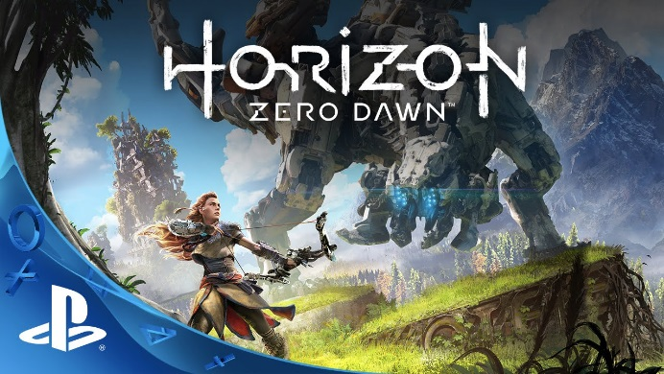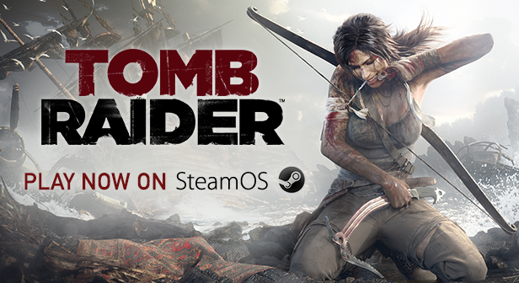

Gestalt = What is the overall gestalt of your game?
- Kloud has a thrilling gestalt with some nostalgic and humorous events because of the puzzle piece memories.

Multiplayer and bonus materials
- This is a single player game.
- The player will be able to continue unlocking additional puzzle piece memories if they would like a more complete back story after completing the game. This will encourage players to continue playing the game or to replay the game.
- Bonus materials and downloadable content can be added if the game gains popularity or a major publisher backs it.

Monetization
The game will be sold on Steam and other PC outlets such as the Windows store for $49.99. If the game is ported to the PS4 and Xbox One consoles then it will retail for $59.99 because that is the standard selling price for new Triple A console games.

