Alone: A School Tale
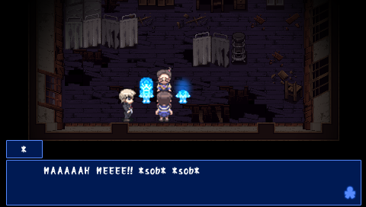
By: Kayla, Victoria, Clayton, Lewis, Jarrett, Courtney
Intended Systems: PC, MAC, Android
Target Age: 10+
Rating: E
Ship Date: TBD

Game Story Summary: In Japan children even as young as 4 or 5 travel alone to school by walking, taking the subway, and other modes of transportation. Some children even travel an hour or more away to get there. Our protagonist, an androgynous kindergarten aged child, will be attempting to go to school far away for the first time all alone. However, the night before the child has an outrageous nightmare about going to school alone. The child will need to walk, take the subway, traverse traffic, be unharmed by other pedestrians, and not fall into obvious traps filled with candy, ice cream, and toys that lure children into dark alleyways. The child must survive all of this in order to get to school successfully and on time in this nightmare. Will the child defeat the nightmare and wake up on time for school? Or will the child be forever tormented in this nightmare and be too afraid to travel to school alone?

Game Flow Outline:
- Start at home
- Walking to subway
- First level / Room - House - grab backpack & breakfast & your lunchbox then leave & grab ammo (whatever you guys want this to be - crayons? You are a 5 yr old)
- Second Level / Room - Walking to subway
- Third Level / Room - On Subway
- As a side note, it’d be messed up to kill a child so if we have an end game screen it should probably just show the child waking up in their room crying from their nightmare or something.

“Alone: A School Tale” is a 2D Isometric view dungeon style platformer where you play as a kindergarten aged child that is afraid of traveling to school alone for the first time. The child’s emotions cause a nightmare that the child becomes trapped in. It is in this nightmare that you as the child must defeat rogue buses, crazy drivers, obey traffic rules, avoid strangers, ride the subway, not succumb to the various shiny temptations that derail most children such as toys, candy, and ice cream, and in the midst of all of this still manage to arrive to school on time by the end of the game. You will need to attack your enemies with either your screaming baby attack or by throwing your crayons. However, before you begin your peril filled journey you start the game at home. You wake up in your room and it is time to travel for school. Before you leave you pick up your backpack. This holds your crayons and textbooks. You also pick up your breakfast to take with you. Once you leave your house you will need to travel to the subway by foot. Be careful on your way to the subway! Their will be many dangers along the way, and once you are on the subway your life does not get any easier. Don’t forget to eat your breakfast if your health starts to deplete! Can you make it school on time and unscathed?
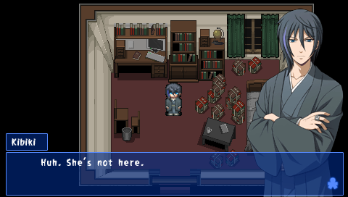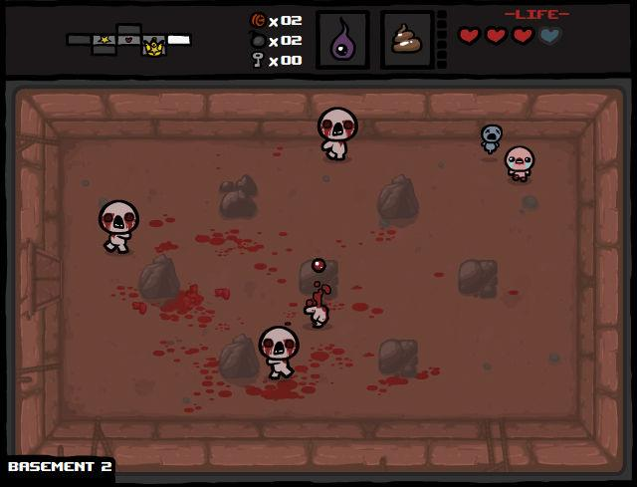

Character:

Androgynous child - Yellow Hat, Blue shirt, shorts as school uniform

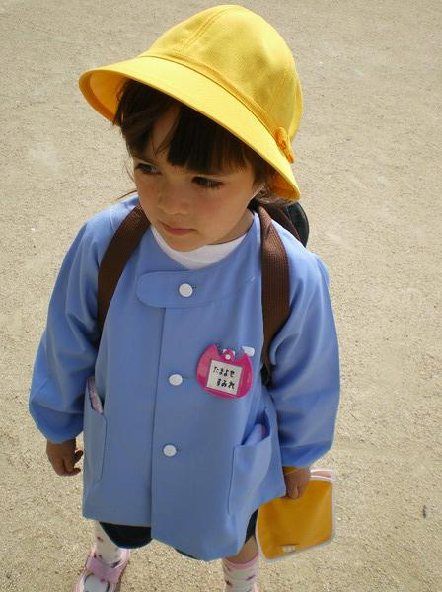

Animations
- walk/run
- idle - standing then crying
- Attack throwing crayons
- Attack Screaming
You are an androgynous child that is about to start kindergarten in Japan. You’ve been shown the path to school before, but this will be your first time going all alone. You are a timid, but bright child. Your parents trust that you will be fine traveling more than an hour to school by yourself because it is the traditional Japanese way, and you are a bright child. Plus your parents also traveled to school alone when they were your age.You are typically happy, but the nightmare that you are trapped in has gotten you down. Your defining traits are your school uniform which consists of your yellow bucket hat, blue shirt,and dark blue shorts. Your appearance is just like every other child in your grade in the city. You do not stand out. Since you are timid you have a tendency to cry when you are startled or are unsure of yourself. Today is the day you need to be brave and venture out on your own to school.
Controls:
This game is meant to be played on the computer and on mobile devices. Therefore a standard keyboard and mouse will be used as the controls on PC and MAC. While touch controls of your finger will be used on the android mobile platform.
W – Move forward
A – Move Left
S – Move Back
D- Move Right
E - Change your weapon between scream and crayon throw attack
Spacebar- Shooting
Mobile - add mouse click option for touch screen controls (your finger is the control)

Gameplay:

This action isometric view sidescrolling (like the binding of isaac) platformer has the main child character navigating a city in order to get to school. The child will need to avoid strangers, not get hit by traffic, cross streets properly, and attack traffic or strange people when necessary. Avoid traps that are distracting to children like candy, toys, and shiny things. Whenever the child needs to consume health the player will need to consume either the breakfast that they took from home with them or any healthy food items that they pick up on the way to school.

As you get farther and farther away from your house the once friendly looking traffic becomes grotesque and scary-looking. The people on the street also become very shady looking.

Game World:
Happy bright colors while inside house
When you step outside it turns scary
Spirited Away for subway level area / map
The world looks like modern day Japan. The game world is very similar to a city like Tokyo or Osaka in Japan. However, because the game is taking place inside a child’s nightmare the game world has a very eerie feeling. The world is so eerie that it even appears to have a purple tint.The streets are very clean just like modern day Japan. There are many stores as well. The subway system resembles modern day subway systems such as Seoul, New York, Washington DC, and Tokyo. The people in the world don’t initially appear creepy. In fact they look normal. However, as the game progresses the people turn eerie just like the world does.

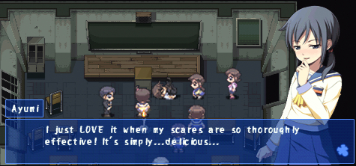
Game Experience: This game will begin on the title screen. There will also be an options menu. The title screen will look eerie like the main nightmare theme of our game. However, the options menu will look bright and spunky like the real world that the main character lives in. When players start the game they will first see an intro scene of happy children in school. Then the player will be taken to their house where they will greet their parents. The night is the night before the first day of school. The player will then receive control of the game.
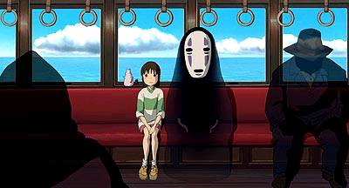
The player will feel happy, but intense while playing this game. This is not only because of the music but also because of the music of the game. The music will be upbeat, but will make your stomach feel like it is turning. The game will make the player want to explore the world more since this is a platforming type of game.

Game Mechanics:
Hazards:
- Red Traffic lights
- Candy, ice cream & toys - picking these up will make you walk backward like in the game Limbo

Abilities:
- Basic Attack 1: Screaming at strangers and traffic will startle your enemies
- Basic Attack 2: Throwing crayons will damage your enemies signicantly
- High Energy: You are a child, so you do not become tired easily. If you consume enough fruits, the sugar from these fruits will let you run through your enemies like Mario does when he eats a Star. (This would be a feature, not for our current prototype)

Enemies:
Strangers (male & female) - Strangers should be attacked by either screaming at them or throwing crayons. Both of these attacks are extremely effective on strangers. Strangers also cause significant damage and have the ability to drop candy and other traps for children.
Traffic (buses, cars, trucks, etc)- Traffic will try to hit you. Avoid at all costs. Similar to real life, if traffic hits you it could be fatal.
Stray animals -
Swarm of Bugs - Bugs are annoying and stay in place. Just don’t jump into their swarm, and you won’t lose any damage.
Bosses
Angry Evil Mean Teacher - You’re second worst nightmare. The teacher attacks with math tests and hard vocabularies. The player must hit the teacher repeatedly with crayons whle avoiding math and vocabulary attacks.
Bigger Jerk Kid - The big jerk kid will attack with wedgies and noogies. Avoid noogies at all cost. These deal the most damage.
Bonus Materials
Throughout the levels there will be some hidden zones that can be found by thorough exploration of the minimap. These zones will contain other children that are traveling to school by themselves. Unlike you, they are not afraid and will give you tips that help you in the game, they will give you more crayon ammo, and if your health is depleting they can even share some of their lunch with you. In these hidden zones can be special tokens, and if all the tokens are found in each level it will give the player an achievement.

Achievements: There will be some achievements to keep the game flowing and player engaged
- Leaving the house – You went outside with your backpack, breakfast, & lunch
- Made it to the Underground Subway! - Complete the first level
- Strangers Beware - Kill 25 strangers with your crayon attack
- Healthy Food Collector - Obtain 25 healthy food items (ie not candy)
- Wow, you’re a screamer - Scream at 25 enemies
- Arrived to your class! – Finish the Game
- Was that a dream? - Finish the game with 50% health or more
Monetization:
The prototype of the game will be freely available to play for fellow GAME 232 students in class. Once the game is released it would be a onetime purchase, but if the player feels they need ,for example, more ammo then they can use in-game purchases to buy more. for the player.

